Environment Details
Cloud Provider: AWS
Service: EC2
OS: Amazon Linux 2023
Instance Type: t2.micro
User: ec2-user (sudo access)

Security Group Configuration
Allow the following inbound ports:
SSH → 22
HTTP → 80
Custom TCP → 8080 (Jenkins)
Custom TCP → 8081 (Nginx)
Custom TCP → 8082 (Tomcat)
- Connect to EC2: ssh -i key.pem ec2-user@

Update System: sudo dnf update -y

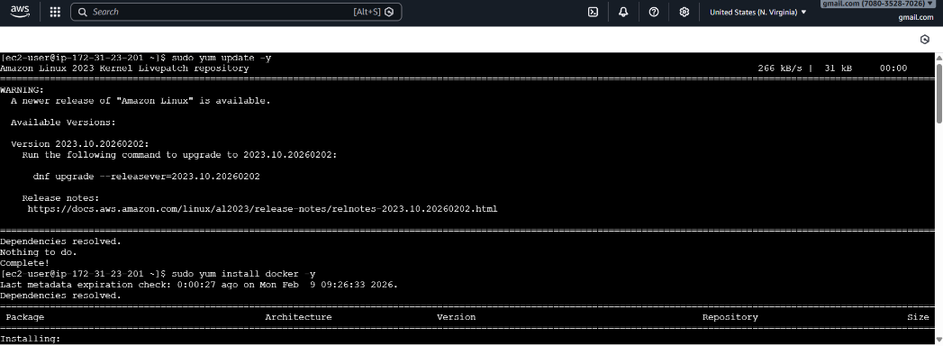

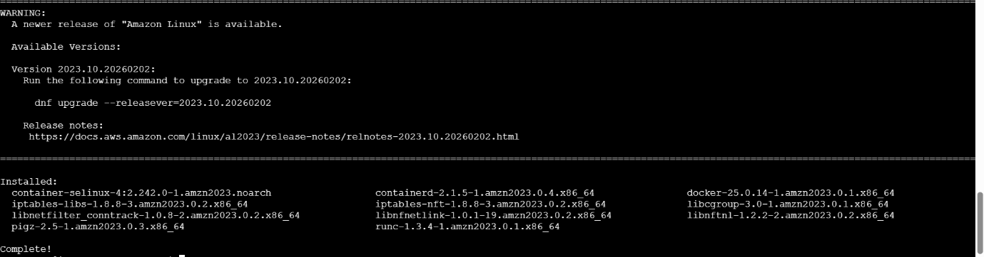

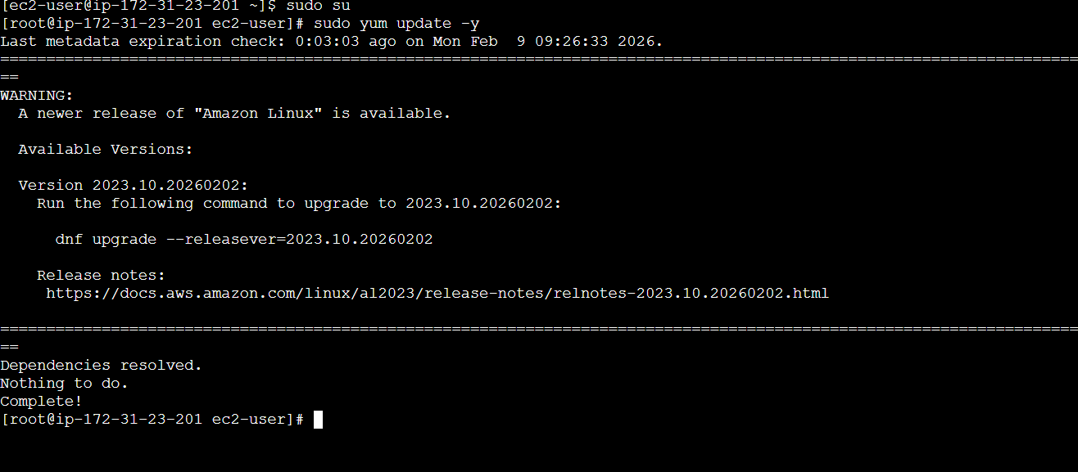

2) Install Docker
sudo dnf install docker -y

sudo systemctl start docker

sudo systemctl enable docker

docker –version

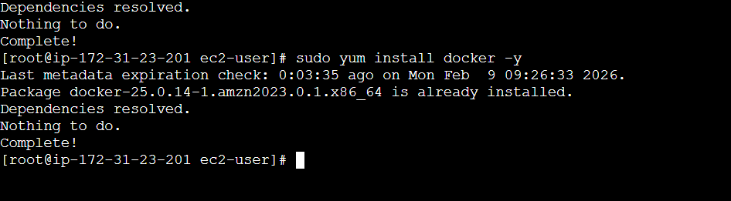

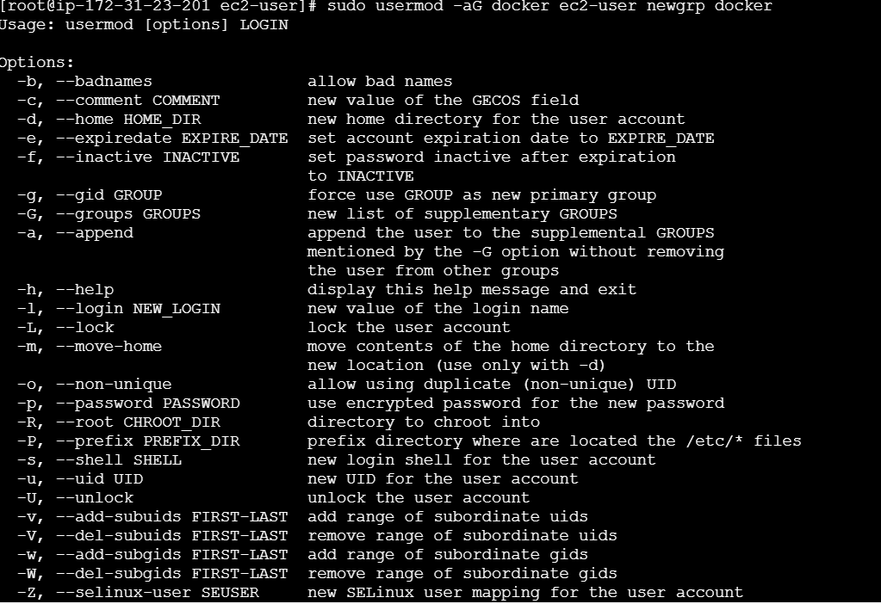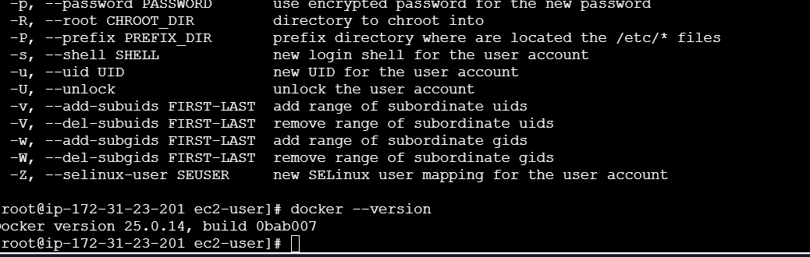

3) Install Jenkins

sudo dnf install java-17-amazon-corretto -y

sudo dnf install jenkins -y

sudo systemctl start Jenkins

sudo systemctl enable jenkins

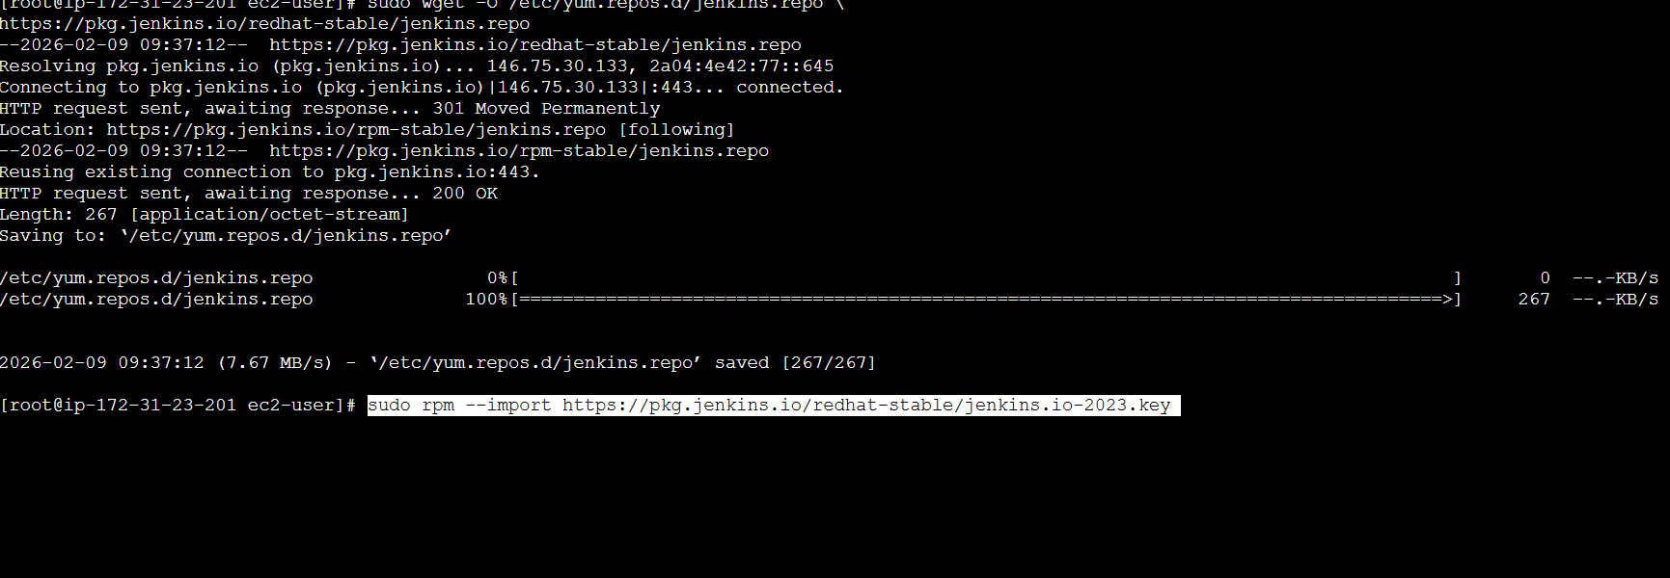

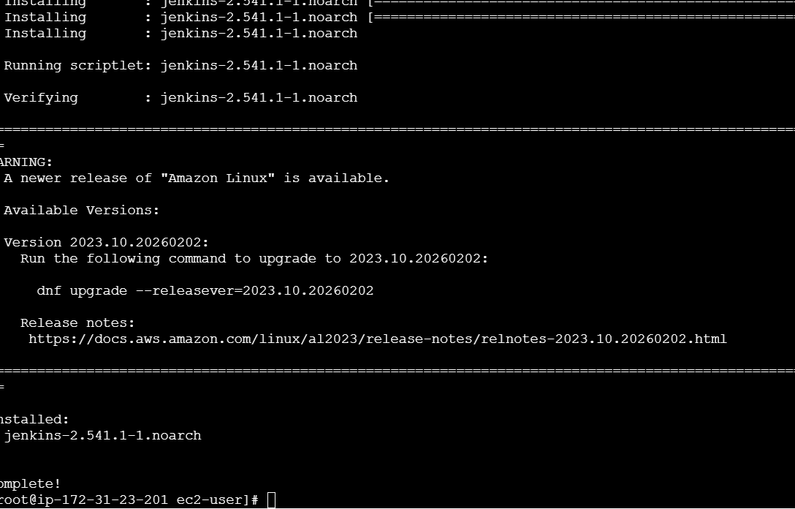

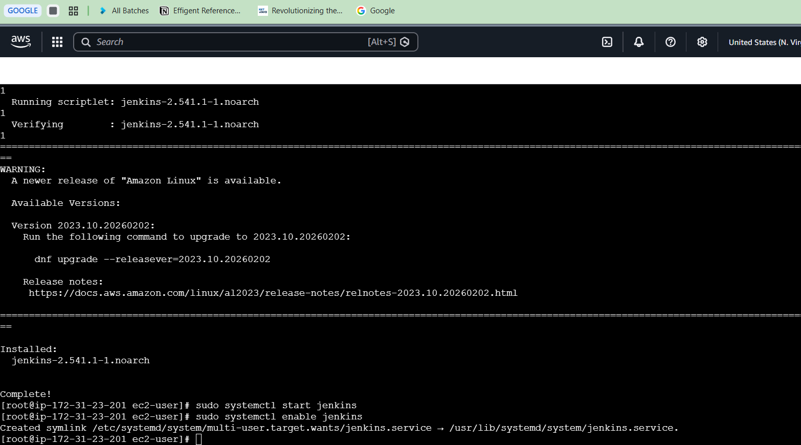

To Access

http://ipaddress:8080

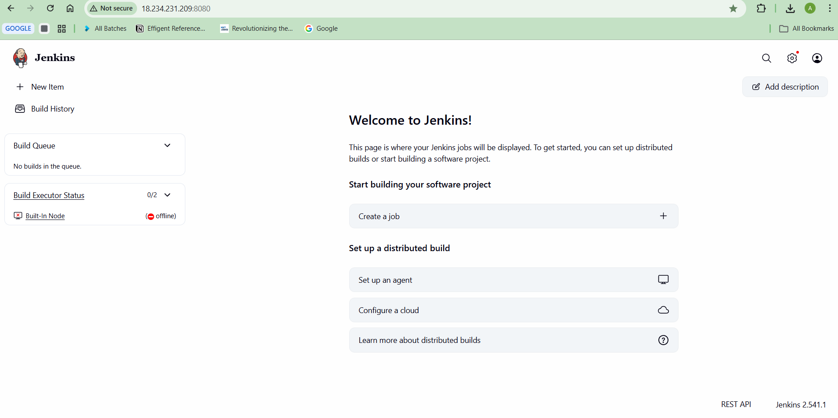

4) Install Apache

sudo dnf install httpd -y
sudo systemctl start httpd
sudo systemctl enable httpd

To Access

http://ipaddress:8080
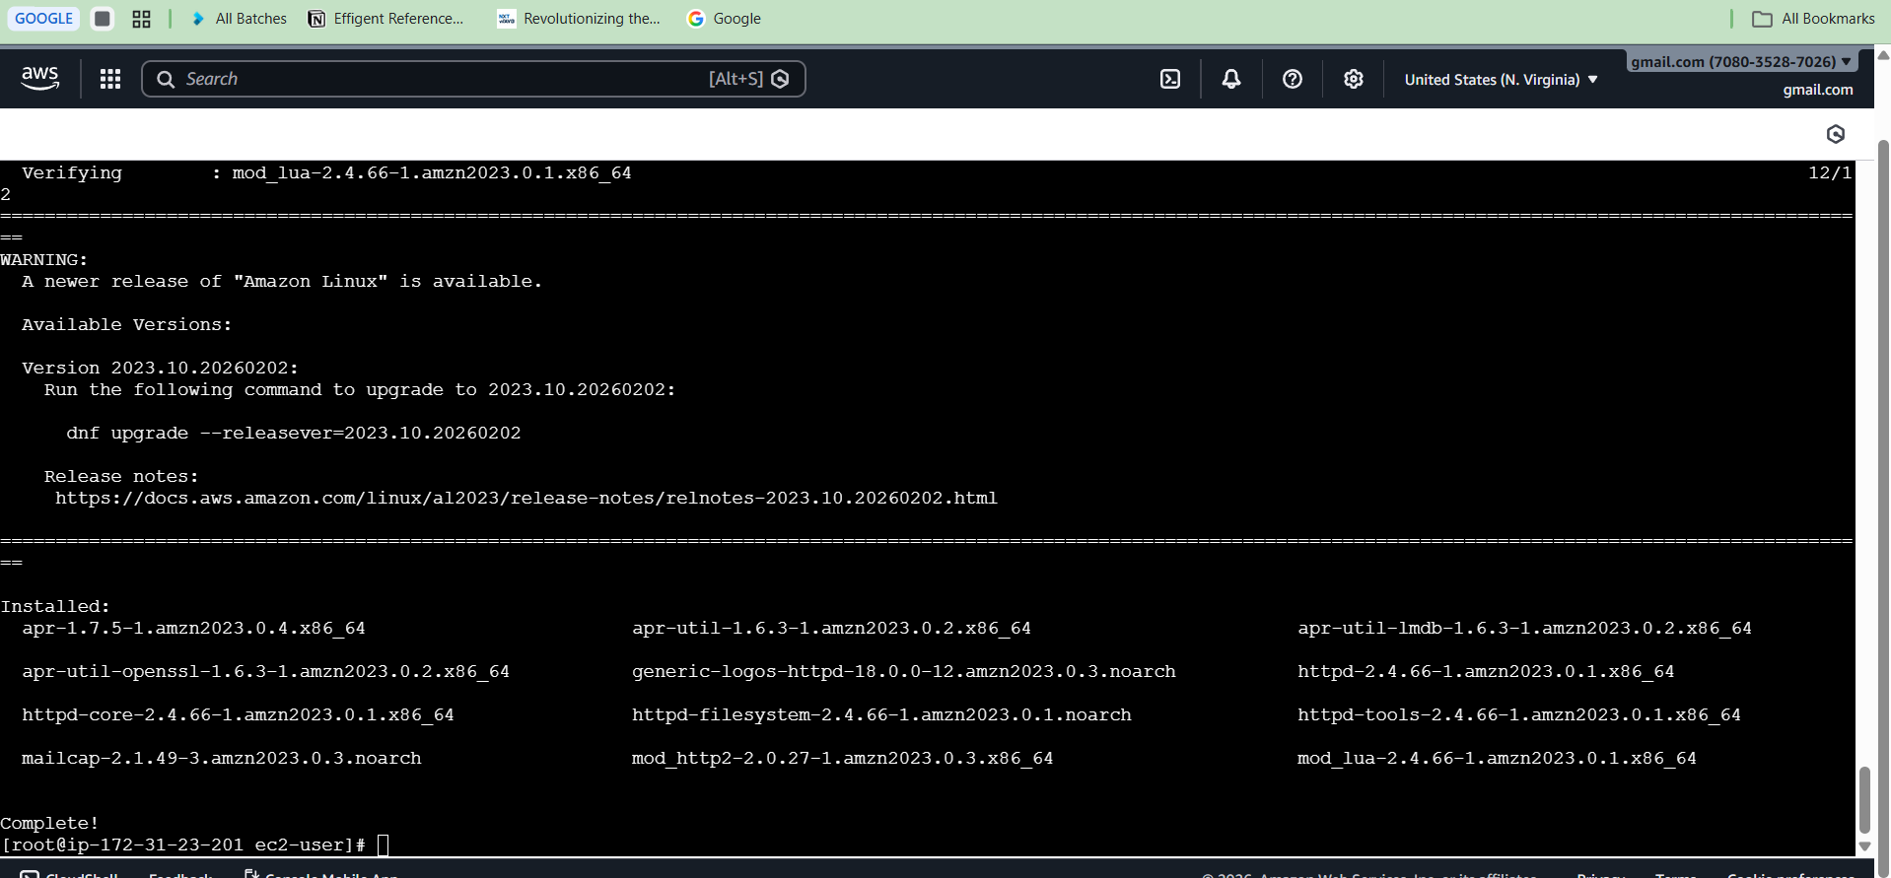

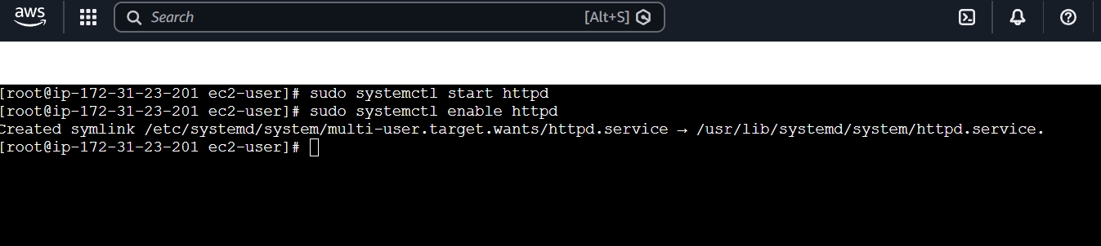

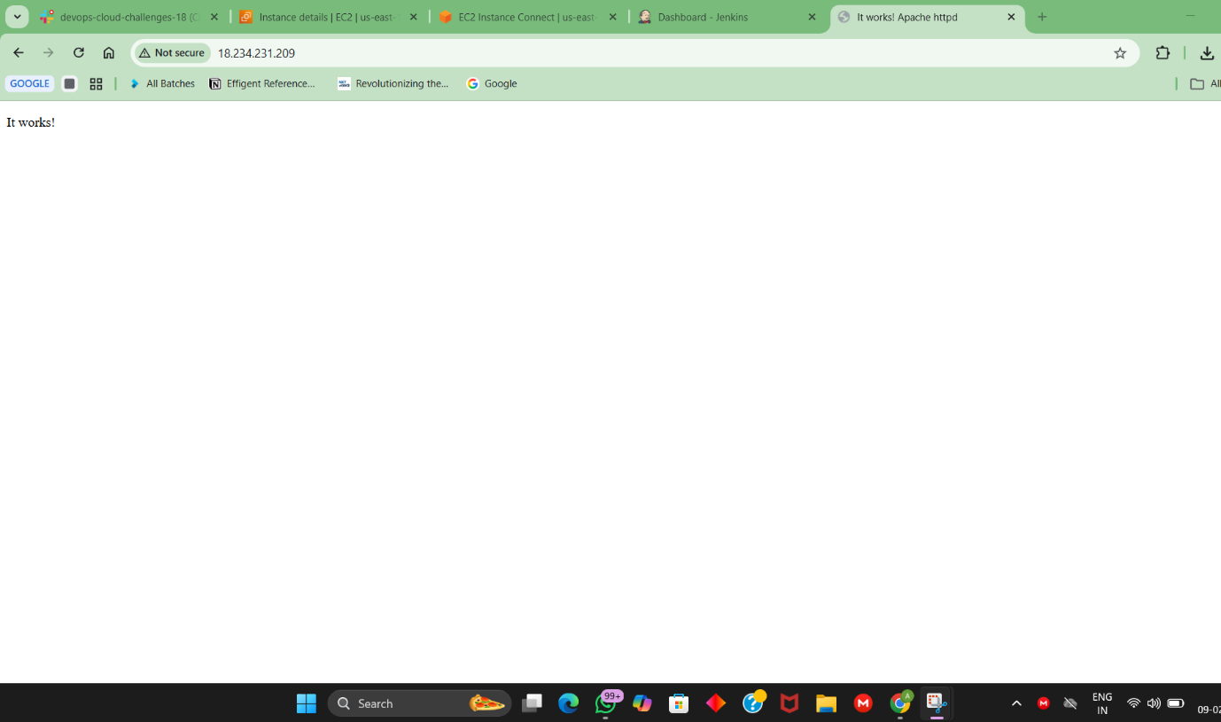

5) Install Nginx
sudo dnf install nginx -y
Change port to 8081
IN
/etc/nginx/nginx.conf
sudo systemctl start nginx
sudo systemctl enable nginx

To Access
http://ipaddress:8081

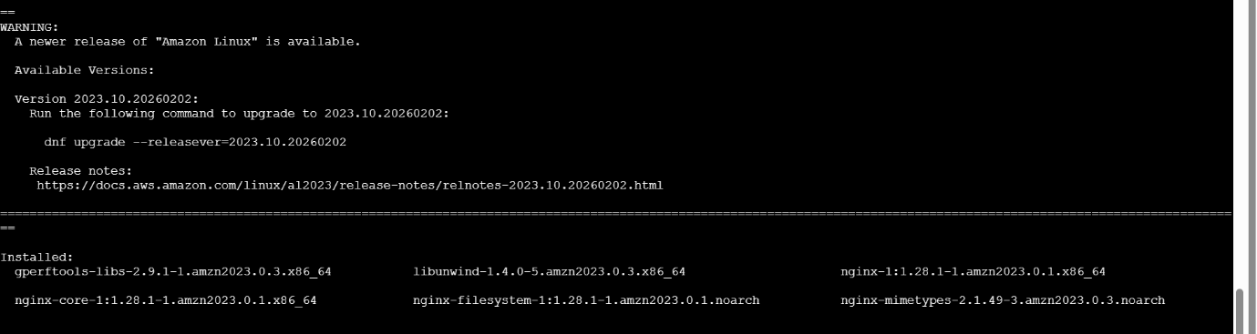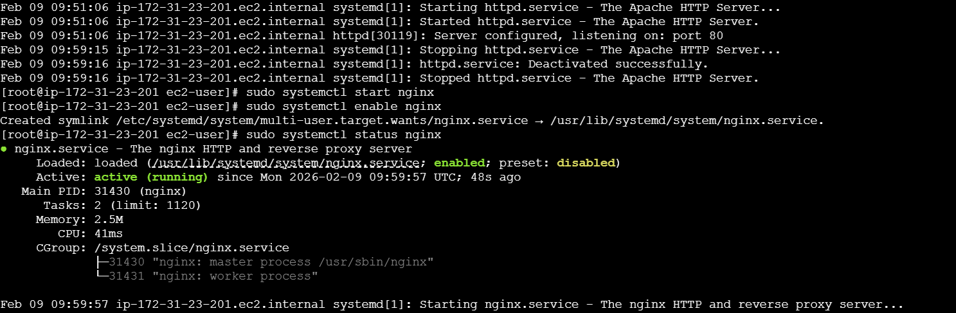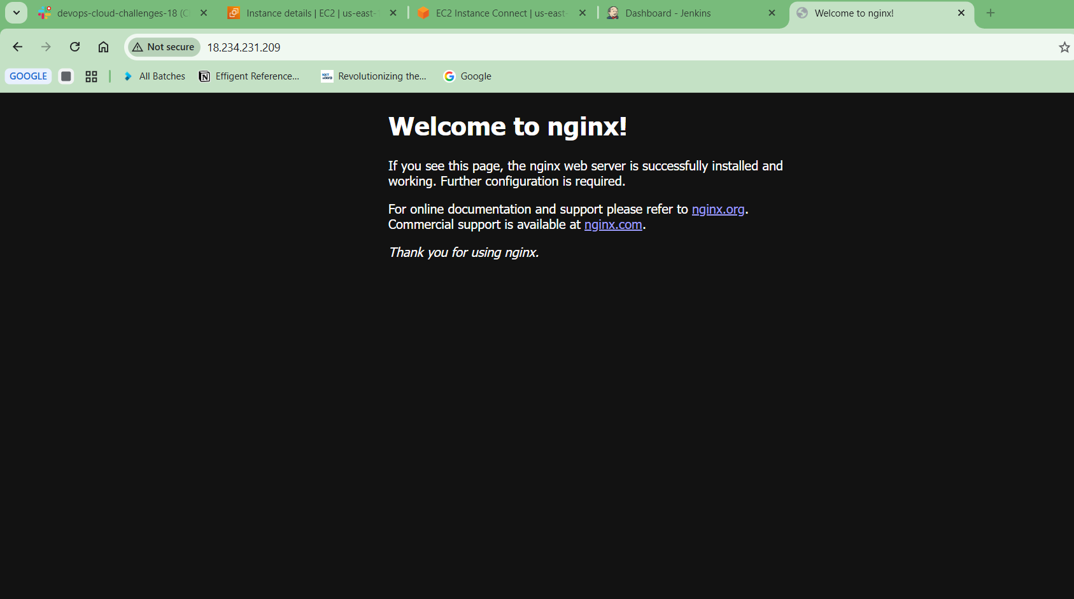
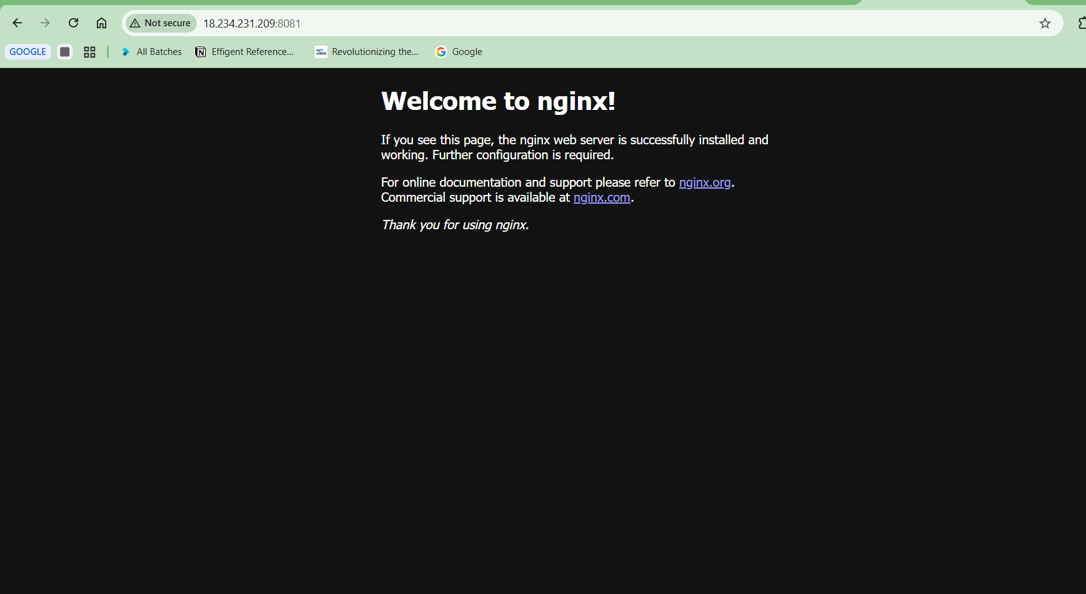

6) Install Tomcat

cd /opt

wget https://archive.apache.org/dist/tomcat/tomcat-9/v9.0.83/bin/apache-tomcat-9.0.83.tar.gz

tar -xvf apache-tomcat-9.0.83.tar.gz

Change port to 8082
IN
server.xml /opt/tomcat/bin/startup.sh

To Access

http://ipaddress:8082

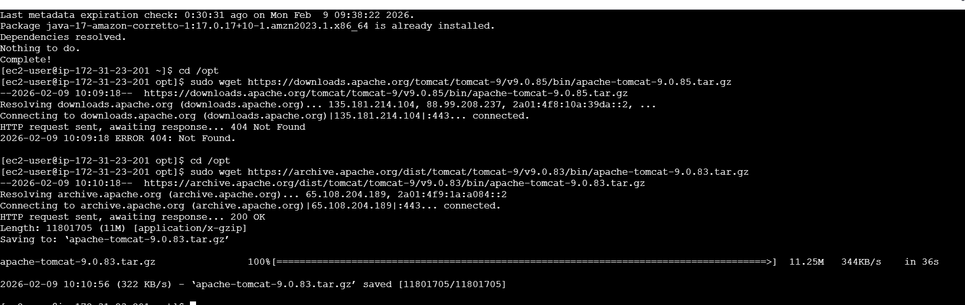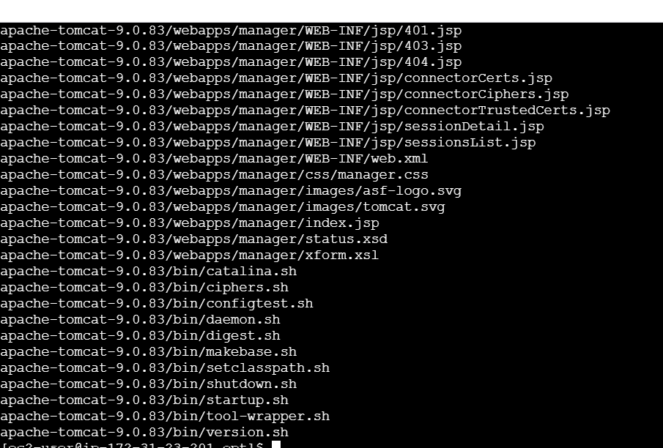
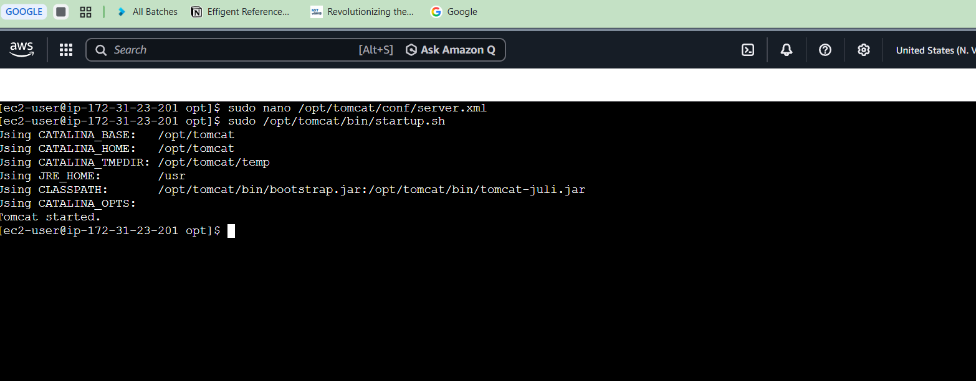
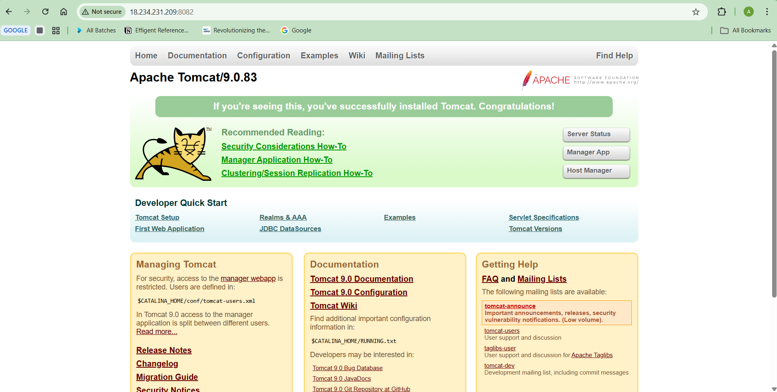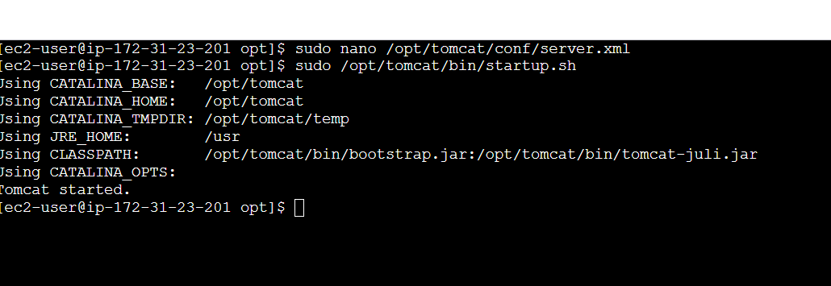

Final Status: All services running successfully on one EC2 instance

